**NAME – Satyajit Panda (IoT summer internship)**

**DATE - 27/06/2022 (MON)**

[Arduino tutorial reference](https://www.ladyada.net/learn/arduino/index.html)

1. Arduino basics

Programmed to blink the port 13 LED

Program



To control an external led along with the builtin LED

Circuit diagram

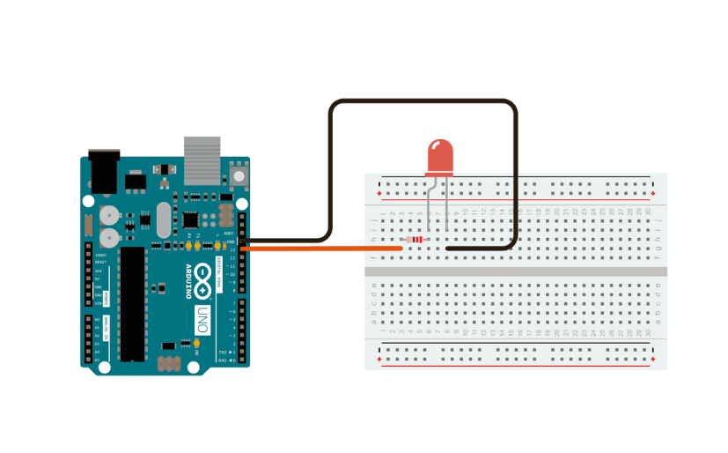  
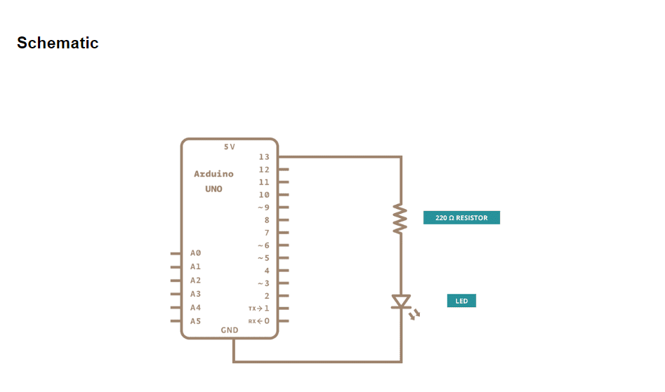

1. Bread board connections

Underlying connections of a breadboard

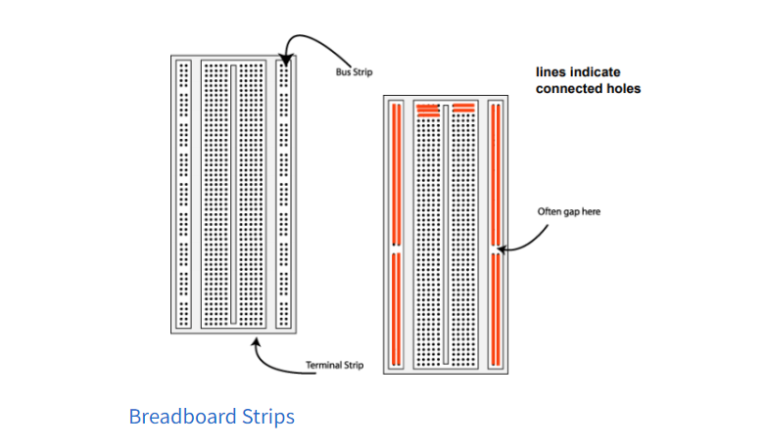

The positive and negative labeled rail like pin holes are called power rails.

Generally they are used for external power supplies, where the column like holes are used for electrical components connections.

The positive and negative signs are only for reference and ease of the user. We can use them as per our convenience.

[reference](https://linuxhint.com/breadboard-arduino/)

Programmed to connect an LED to the breadboard.

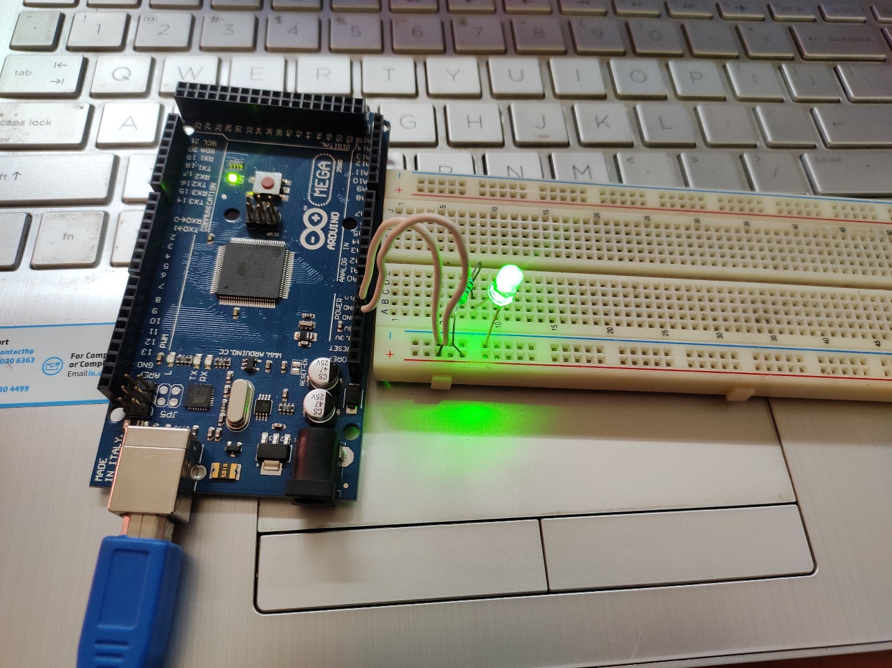

This is the normal analog connection of an LED with the Arduino board

We also can connect it with the digital 13 pin and digital ground to synchronize the external LED with the inbuilt LED (13).

**DATE – 28/06/2022 (TUE)**

1. Parallel connection on LEDS on bread board and blinking them

Program



Both the LEDs are connected to pin 5, and we use the pin to control at what time interval it should set it high and low.

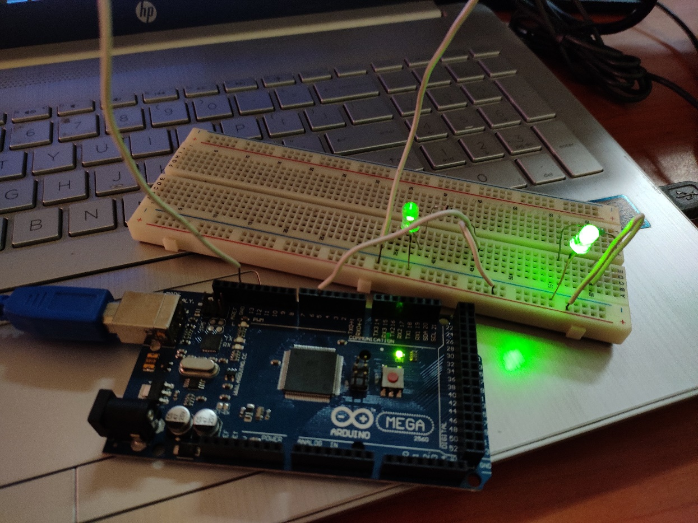

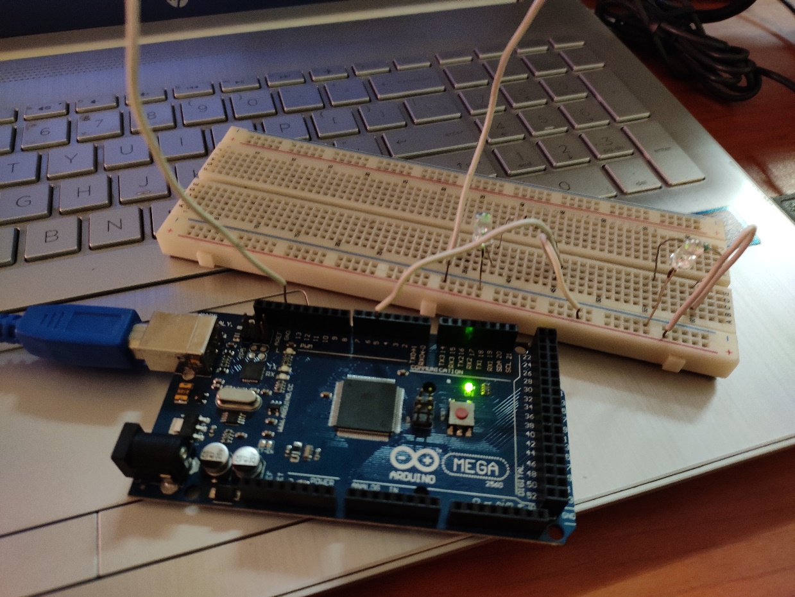

1. Checking BPM using a heart rate pulse sensor

About pulse sensor

The pulse sensor has 3 pins VCC, GND and analog pin.

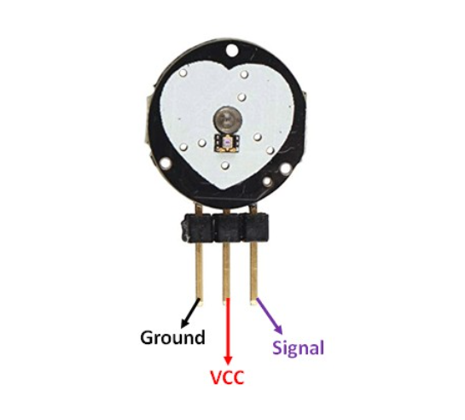

To use it we just have to plug it with the Arduino and place the sensor on our fingertip. It provides live heart rate to use in our projects.

There is a heart logo on the front side of the sensor. On this we have to put our fingers on. The small round hole inside the heart logo, where a flash green led shines is a small ambient light photo sensor.

The heart rate sensor is connected with the Arduino with its power input (red wire) to 3.3/5v supply, blue wire to GND and the ac signal output (purple wire) to A0 AC input of Arduino.

[reference](https://how2electronics.com/pulse-rate-bpm-monitor-arduino-pulse-sensor/)

Circuit diagram for the electrical connection

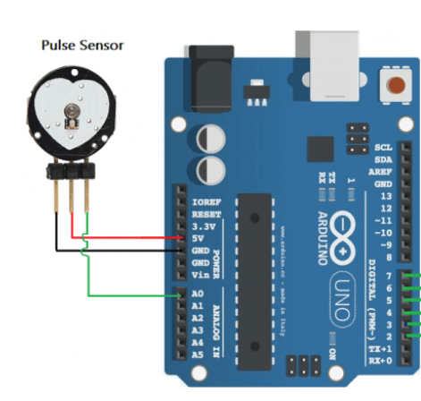

As we are using the serial monitor and serial plotter to visualize the output, we don’t need any external device for this purpose.

Working principle of the sensor

When a heartbeat occurs, blood is pumped through the human body and gets squeezed into the capillary tissues. Consequently, the volume of these capillary tissues increases. But in between the two consecutive heartbeats, this volume inside capillary tissues decreases. This change in volume between the heartbeats affects the amount of light that will transmit through these tissues. This can be measured with the help of a microcontroller.

The pulse sensor module has a light that helps in measuring the pulse rate. When we place the finger on the pulse sensor, the light reflected will change based on the volume of blood inside the capillary blood vessels. This variation in light transmission and reflection can be obtained as a pulse from the output of the pulse sensor. This pulse can be then conditioned to measure heartbeat and then programmed accordingly to read as heartbeat count using Arduino.

Program for observing the heart rate in serial plotter



Serial Plotter output

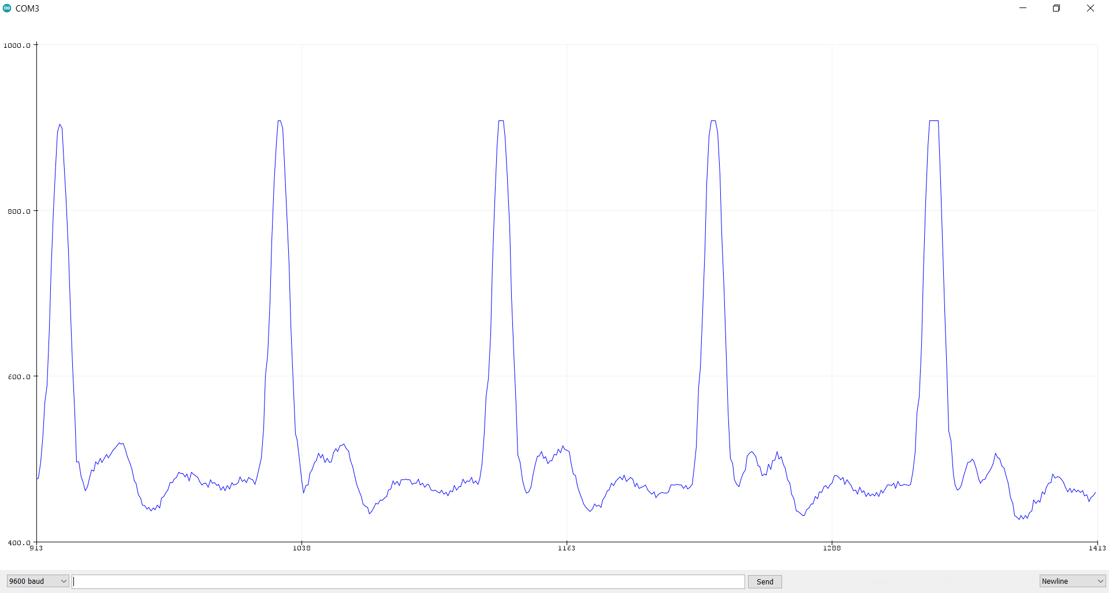

Program to display the BPM in the serial monitor



Serial Monitor output

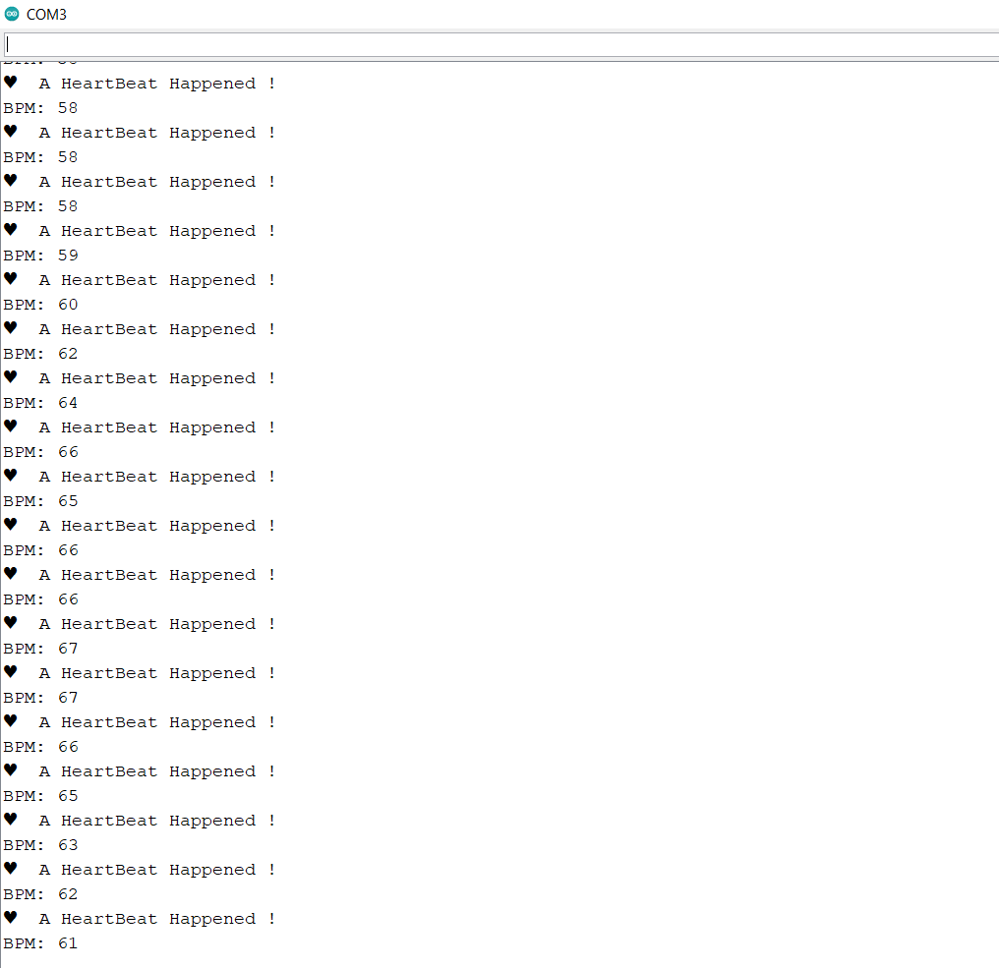

**DATE – 29/06/2022 (WED)**

1. Converting the serial monitor data into a csv file and storing it

Coolterm software is used to export the serial monitor data and to store it in a txt file, then we convert this txt into a csv(comma separated values) file.

[referenece](https://www.youtube.com/watch?v=RWgyCcnUxPY)

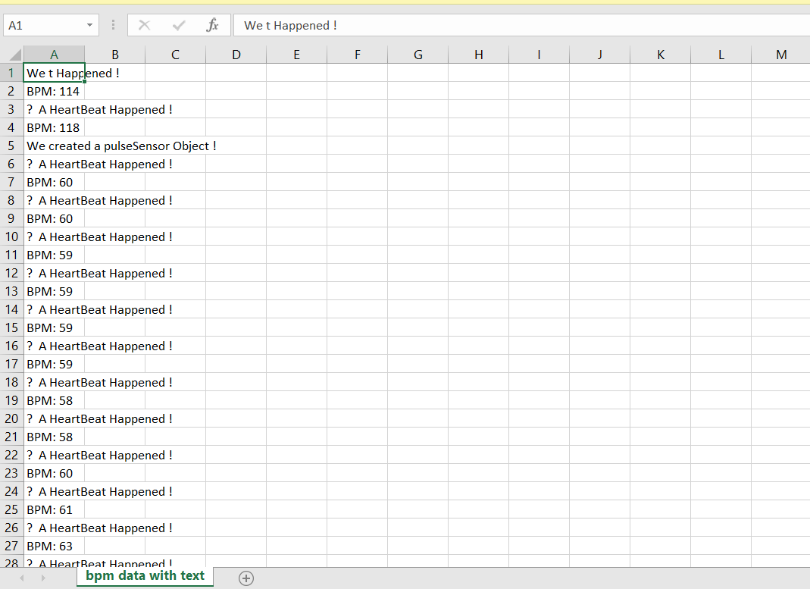

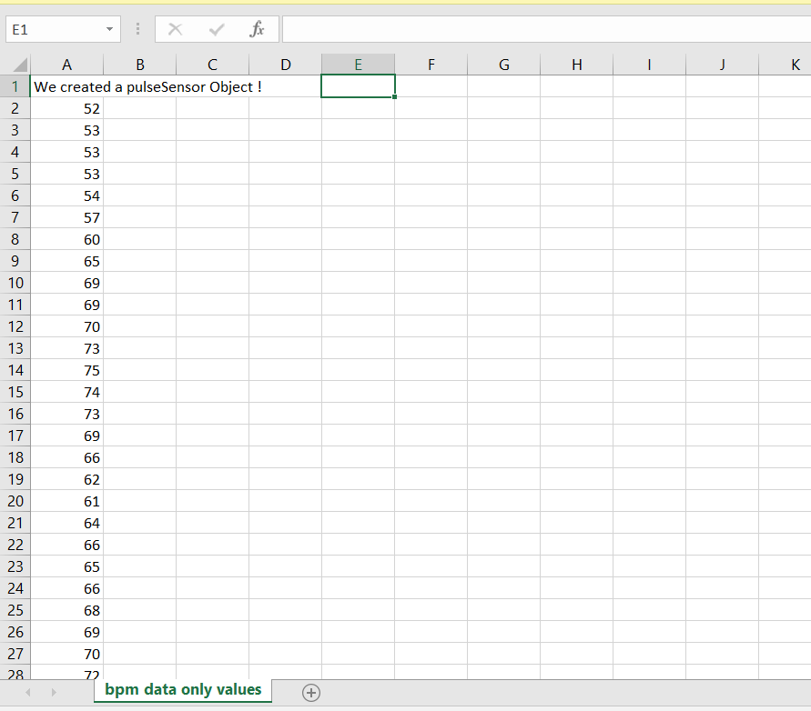

1. Read about basics of python

[reference](https://github.com/Asabeneh/30-Days-Of-Python)

**DATE – 30/06/2022 (THU)**

Basic python programs done.

1. Program to calculate BMI

mass=int(input("enter your weight : "))

height=int(input("enter your height in centimetre : "))

bmi=mass/pow(height/100,2)

print("your BMI is ",'%.2f'%bmi)

output

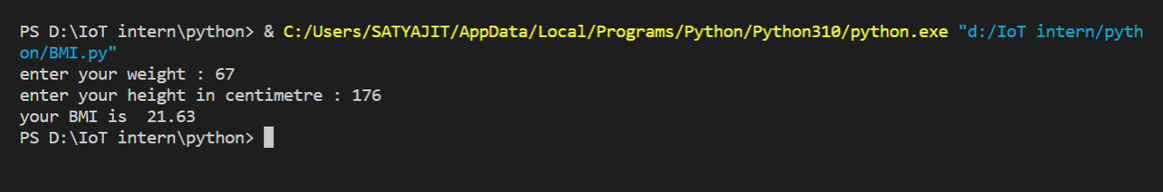

1. Program to know a year is leap year or not

year = int(input("enter the year to check : "))

if year%4==0 :

    if year%100==0 and year%400==0:

        print("it is a leap year")

    elif year%100==0:

        print("it is not")

    else:

        print("it is a leap year")

else:

    print("it is not")

output

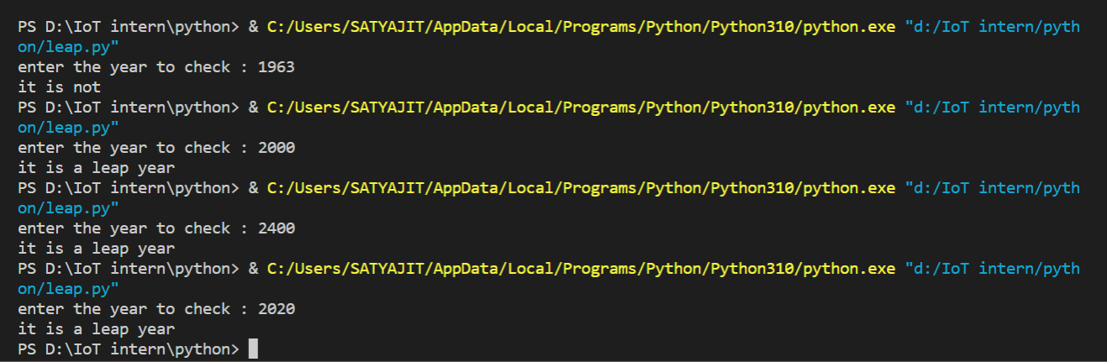

1. Program for tip caluculator

sum=int(input("enter the original amount : "))

pct=int(input("enter the tip % : "))

tip=int(sum*(1+(pct/100)))

print("the tip amount is : ",tip)

output

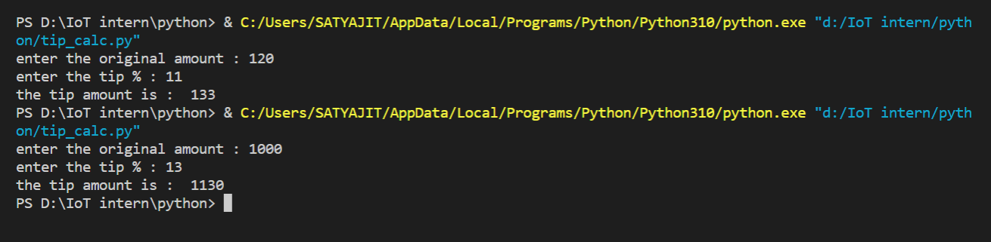

**DATE – 04/07/2022 (MON)**

1. The maze problem

print("you are at the starting position")

print("the available moves are left, right, up and down")

current = input("enter your move : ")

current = current.lower()

if current == "left": ## starting position

    print("You can't go left from starting, you are dead")

elif current == "right": ## position 1

    print("you are on the right track, move ahead")

    print("from here you can move up,down and right")

    current = input("enter your move : ")

    current = current.lower()

    if current=="up": ## position 2

        print("you got a right move but there is wall ahead, so start again")

    elif current=="right": ## position 4

        print("you are on the right track, go ahead")

        current = input("choose left or right : ")

        current = current.lower()

        if current == "up" or current=="left" or current == "right":

            print("no up or down or right moves are available from here, start again")

        elif current=="down": ## position 5

            print("you are on the right track, move ahead")

            current = input("enter your move : ")

            current = current.lower()

            if current=="left" or current=="up" or current=="down":

                print("no up, down or left moves available here, start again")

            elif current=="right": ## position 6

                print("hurray, you reached at the end 😊😊 !!!")

            else:

                print("invlaid input, start again")

        else:

            print("invalid input, start again")

    elif current=="down": ## position 3

        print("you are on the right track, move ahead")

        current = input("enter your move : ")

        current = current.lower()

        if current=="up" or current=="left" or current=="down":

            print("no left or up or down moves are availabe here, start again")

        elif current=="right": ##position 5

            print("you are on the right track, move ahead")

            current = input("enter your move : ")

            current = current.lower()

            if current=="left" or current=="up" or current=="down":

                print("no up, down or left moves available here, start again")

            elif current=="right": ## position 6

                print("hurray, you reached at the end 😊😊 !!!")

            else:

                print("invlaid input, start again")

        else:

            print("invalid move, start again")

    elif current=="left":

         print("no left moves are available from here, start again")

    else:

        print("invalid move, start again")

elif current=="up" or current=="down":

    print("no up or down moves are available from here, start again")

else:

    print("invalid input")

output

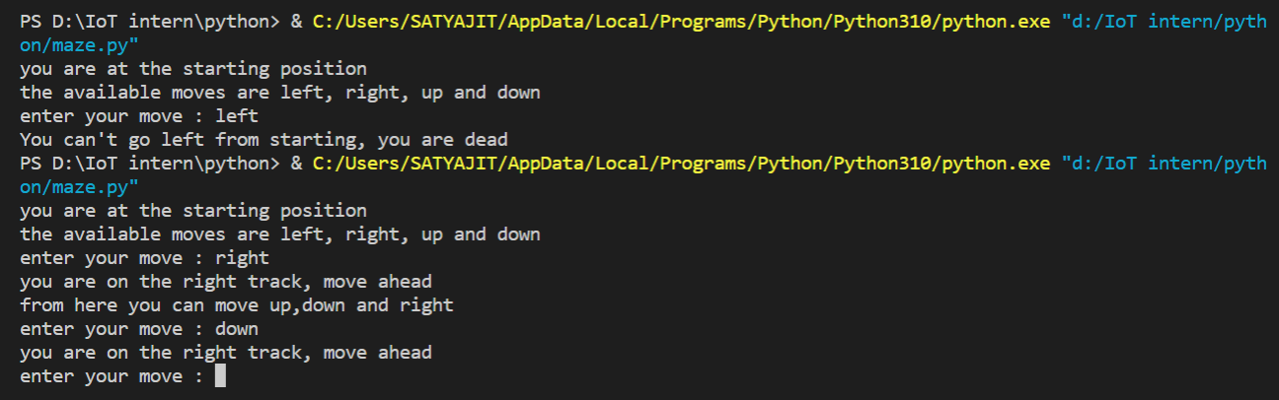

1. True-love calculator program

p_name = input("enter the 1st person name : ")

q_name = input("enter the 2nd person name : ")

p_name = p_name.lower()

q_name = q_name.lower()

count1 = 0

count2 = 0

for character in p_name:

    if "true".find(character)!=-1:

        count1+=1

    if "love".find(character)!=-1:

        count1+=1

for character in q_name:

    if "true".find(character)!=-1:

        count2+=1

    if "love".find(character)!=-1:

        count2+=1

ans = count1*10 + count2

if ans<=10 or ans>=90:

    print("Your score is ",ans,", you go together like coke and mentos")

elif ans>=40 and ans<=50:

    print("Your score is ",ans,", you are alright together")

else:

    print("Your score is ",ans)

output

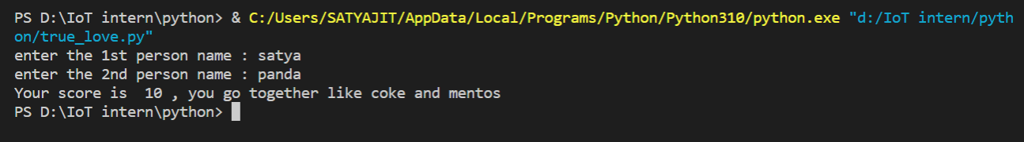

1. Dice game problem

import random

decision = input("You want to roll the dice Y/N")

if  decision=='y'or decision=='Y':

    print(random.randint(1,6))

output

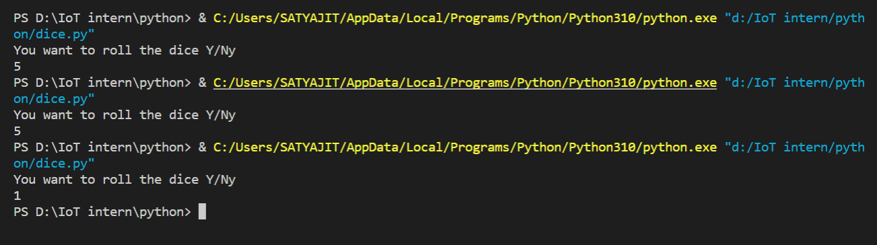

1. Password generator problem

import random

arr = ["A", "B", "C", "D", "E", "F", "G", "H", "I", "J", "K", "L", "M", "N", "O", "P", "Q", "R", "S", "T", "U", "V", "W", "X", "Y", "Z", "a", "b", "c", "d", "e", "f", "g", "h", "i", "j", "k", "l", "m", "n", "o", "p", "q", "r", "s", "t", "u", "v", "w", "x", "y", "z",'1','2','3','4','5','6','7','8','9','!','@','#','$','%','^','&','*','(',')','[',']','{','}']

l=len(arr)

inp = input("enter y to generate a new password : ")

if inp=='y':

    res=""

    for i in range(8):

        num=random.randint(0,l)

        res+=arr[num]

    print("the password is : ",res)

else:

    print("invalid input")

output

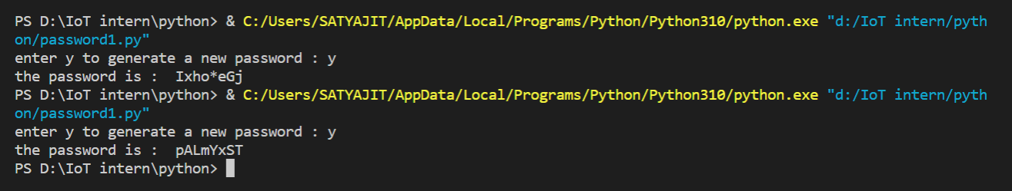

Connecting Arduino with things speak to view the sensor data online

**DATE – 05/07/2022 (TUE)**

Exploring how we can send Arduino sensor data online

**DATE – 06/07/2022 (WED)**

1. How to use IR sensor data with Arduino

Components used – Arduino, jumper wires, IR sensor, LED light, cable

Infrared Sensor is an electronic instrument that is used to detect any type of obstacle/object

We are using an Arduino diecimila here.

The sender and receiver end of the IR sensor is as below.

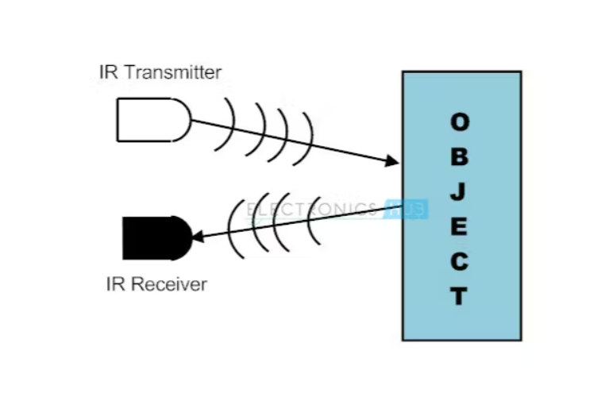

The circuit connection is like

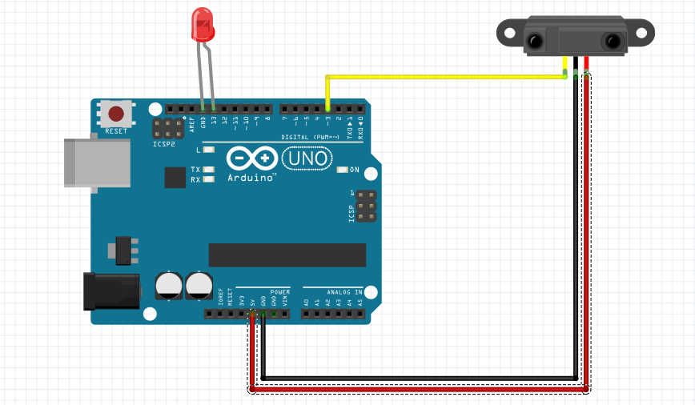

Code



[reference](https://create.arduino.cc/projecthub/biharilifehacker/how-to-use-ir-sensor-with-arduino-with-full-code-bihar-3f29c3)

**Output pictures**

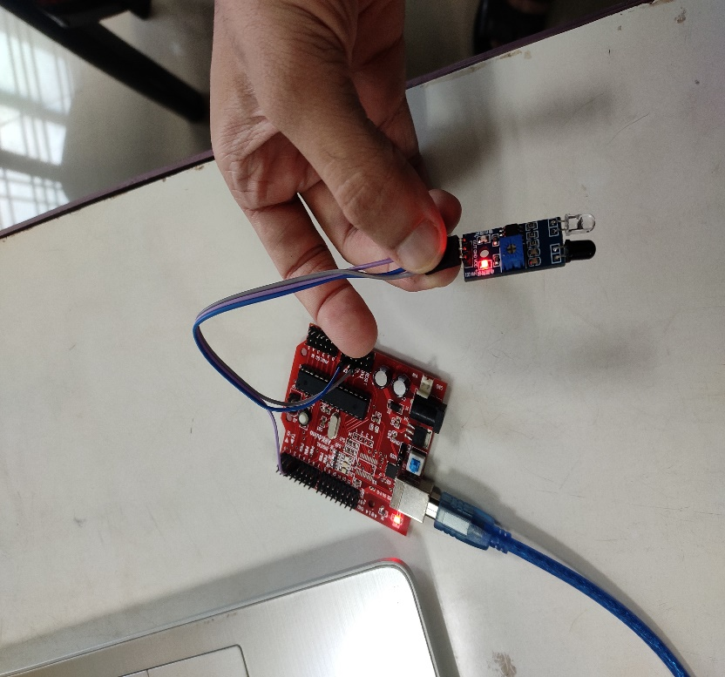

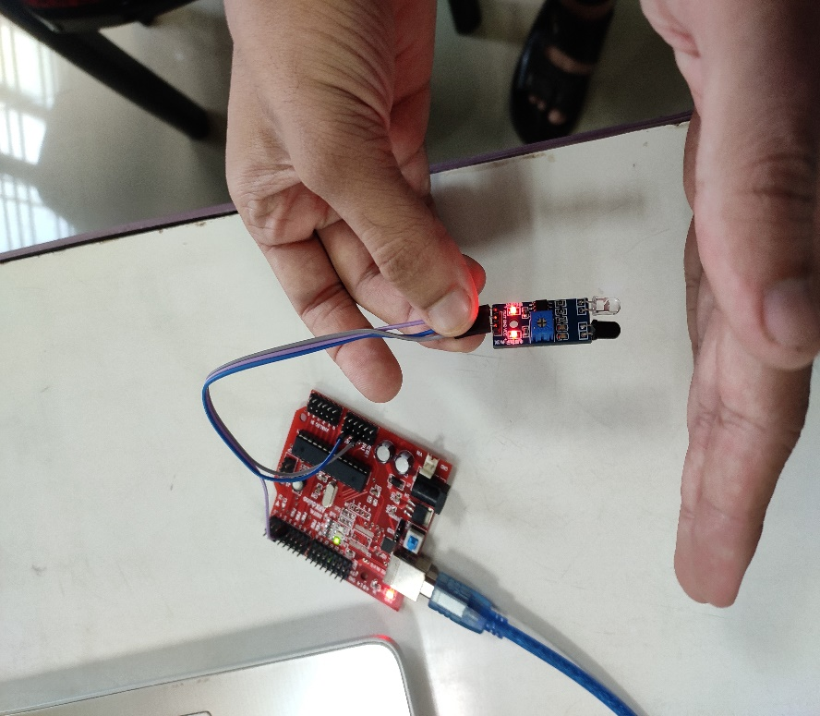

**DATE – 07/07/2022**

1. **Stepper motor connection with Arduino**

Components used – Arduino diecimila, 28BYJ-48 stepper motor, driver

The driver is connected with the Arduino with 5v power supply and ground.

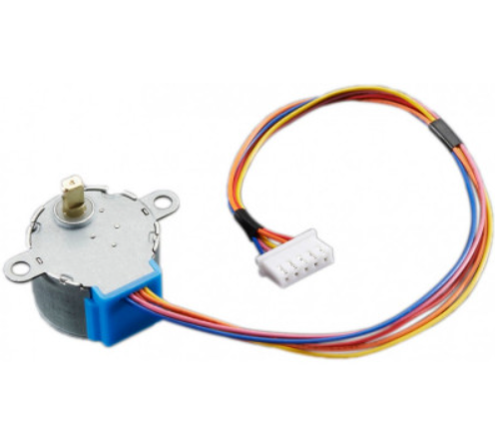

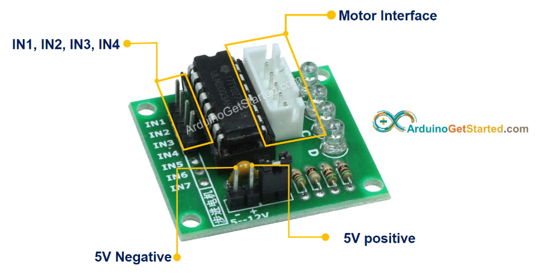

Connection

The IN1, IN2, IN3, IN4 are connected to the 12, 11, 10 and 9 digital pins of the Arduino diecimila.

The step motor 28BYJ-48 (5V DC) is connected with the driver in the provided port.

The Arduino is connected to the system and the code is uploaded.

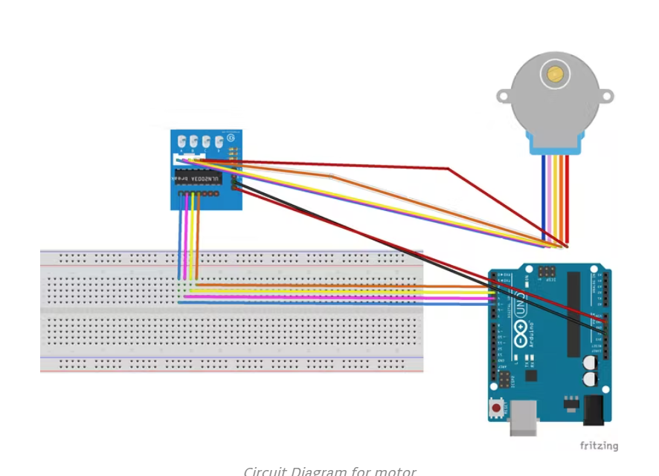

**Circuit photo**

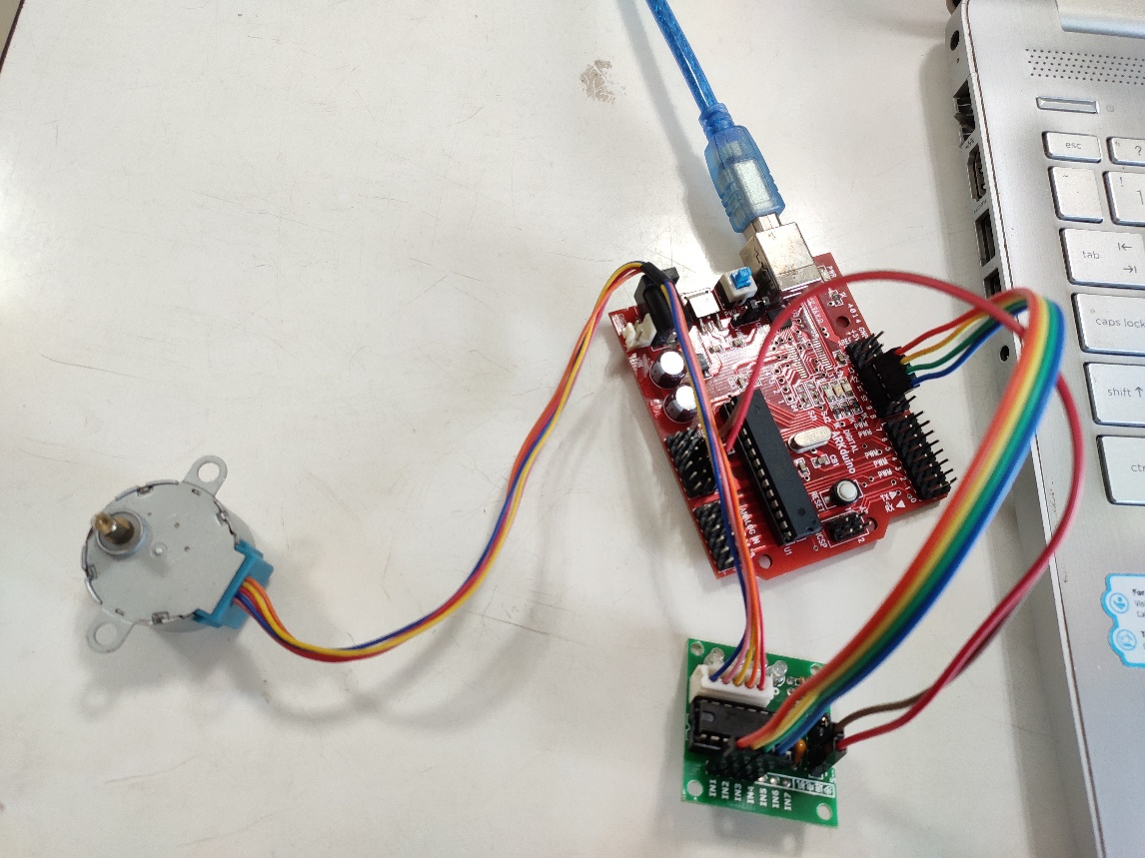

**Code**

#define STEPPER_PIN_1 9

#define STEPPER_PIN_2 10

#define STEPPER_PIN_3 11

#define STEPPER_PIN_4 12

int step_number = 0;

void setup() {

pinMode(STEPPER_PIN_1, OUTPUT);

pinMode(STEPPER_PIN_2, OUTPUT);

pinMode(STEPPER_PIN_3, OUTPUT);

pinMode(STEPPER_PIN_4, OUTPUT);

}

void loop() {

OneStep(false);

delay(2);

}

void OneStep(bool dir){

if(dir){

switch(step_number){

case 0:

digitalWrite(STEPPER_PIN_1, HIGH);

digitalWrite(STEPPER_PIN_2, LOW);

digitalWrite(STEPPER_PIN_3, LOW);

digitalWrite(STEPPER_PIN_4, LOW);

break;

case 1:

digitalWrite(STEPPER_PIN_1, LOW);

digitalWrite(STEPPER_PIN_2, HIGH);

digitalWrite(STEPPER_PIN_3, LOW);

digitalWrite(STEPPER_PIN_4, LOW);

break;

case 2:

digitalWrite(STEPPER_PIN_1, LOW);

digitalWrite(STEPPER_PIN_2, LOW);

digitalWrite(STEPPER_PIN_3, HIGH);

digitalWrite(STEPPER_PIN_4, LOW);

break;

case 3:

digitalWrite(STEPPER_PIN_1, LOW);

digitalWrite(STEPPER_PIN_2, LOW);

digitalWrite(STEPPER_PIN_3, LOW);

digitalWrite(STEPPER_PIN_4, HIGH);

break;

}

}else{

switch(step_number){

case 0:

digitalWrite(STEPPER_PIN_1, LOW);

digitalWrite(STEPPER_PIN_2, LOW);

digitalWrite(STEPPER_PIN_3, LOW);

digitalWrite(STEPPER_PIN_4, HIGH);

break;

case 1:

digitalWrite(STEPPER_PIN_1, LOW);

digitalWrite(STEPPER_PIN_2, LOW);

digitalWrite(STEPPER_PIN_3, HIGH);

digitalWrite(STEPPER_PIN_4, LOW);

break;

case 2:

digitalWrite(STEPPER_PIN_1, LOW);

digitalWrite(STEPPER_PIN_2, HIGH);

digitalWrite(STEPPER_PIN_3, LOW);

digitalWrite(STEPPER_PIN_4, LOW);

break;

case 3:

digitalWrite(STEPPER_PIN_1, HIGH);

digitalWrite(STEPPER_PIN_2, LOW);

digitalWrite(STEPPER_PIN_3, LOW);

digitalWrite(STEPPER_PIN_4, LOW);

}

}

step_number++;

if(step_number > 3){

step_number = 0;

}

}

**DATE – 08/07/2022**

Attempts to upload sensor data to online

Wifi scanned but the connection not made

The esp device is connected with the computer with a micro usb cable.

Code



**DATE – 11/07/2022**

Manual data uploaded to thingspeak.

Normal signal from heart rate sensor worked, but the bpm convertor did not work with esp.

Thingspeak is an IoT analytics platform service that allows you to aggregate, visualize, and analyze live data streams in the cloud. You can send data to Thingspeak from your devices, create instant visualization of live data, and send alerts.

To use thingspeak in our project, we have to first create a new channel and connect that channel with our code with the channel ID and API keys.

Creating a channel in thingspeak [reference](https://in.mathworks.com/help/thingspeak/collect-data-in-a-new-channel.html)

1. 1st we have to sign in by giving the mathworks credentials.
2. Then go to channels->my channels



3 - On the channel page click on new channel.

4 - Then select and name the number of filds we want to upload.

5 - Finally save the channel.

We can access the channel ID and the read and write API keys now.

Code to connect the esp to the wifi only



code to connect the esp with the thingspeak channel



**DATE – 12/07/2022**

Fedora downloaded and installation on virtual box.

Brave browser installation on fedora.

**DATE – 13/07/2022**

VS code installation on fedora

Downloading raspberry pi imager, vnc viewer and putty.

**DATE – 14/07/2022**

Raspberry pi set up

The Raspberry Pi is a low cost, **credit-card sized computer** that plugs into a computer monitor or TV, and uses a standard keyboard and mouse. It is a capable little device that enables people of all ages to explore computing, and to learn how to program in languages like Scratch and Python. It’s capable of doing everything we’d expect a desktop computer to do, from browsing the internet and playing high-definition video, to making spreadsheets, word-processing, and playing games.

We can use raspberry pi to learn code, or to do projects related to IoT and electronics. Raspberry pi operates in a open source eco system. Its main supported operating system PI os is open source also.

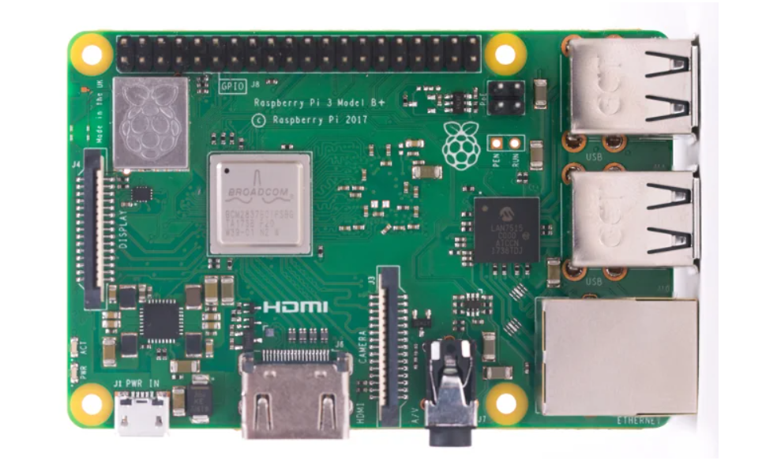

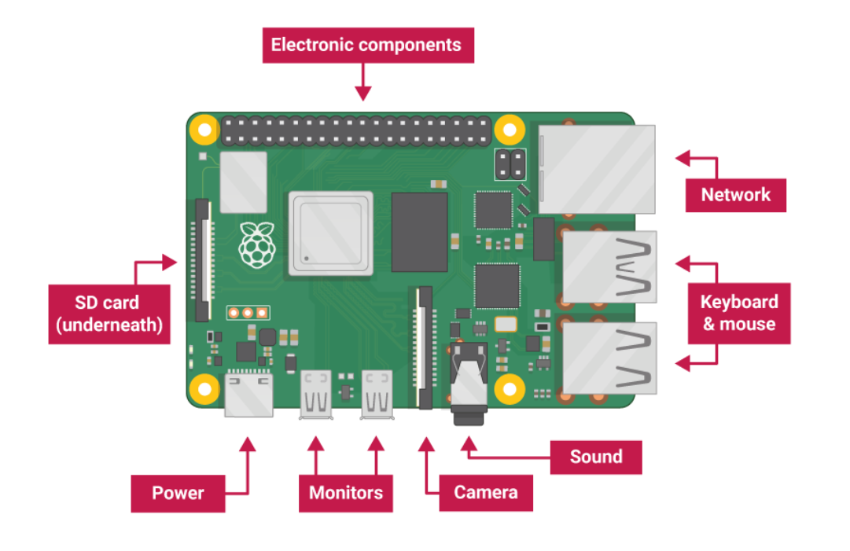

[Tutorial reference](https://projects.raspberrypi.org/en/projects/raspberry-pi-setting-up/0)

First we have to download and install putty and vnc viewer software in our laptop. Then we insert the sd card in the raspberry pi and connect it with a LAN cable with the laptop. We have to provide the raspberry pi a external power supply through the micro usb also.

Putty configuration

1. We open putty and enter the host name as raspberrypi.local and leave all those settings as default and hit open.
2. If everything goes right, we will see a pop up warning, press yes.
3. Now the raspberry terminal will open. We have to enter the id as “pi” and password as “raspberry”. We can do things from here also. It is the same raspberry pi terminal.
4. Now we want to view our raspberry interface through vnc viewer. So type the below command in the raspberry pi terminal.

sudo raspi -config

1. It will open a configuration menu. We will go to interfacing options.

Choose vnc -> enable it

1. The set up is done here. Now we will open the vnc viewer and enter our address “raspberrypi.local”.
2. It will ask for the user id and password. We will enter that as we have set it up and click ok. Our raspberry pi interface window will come now.

Configuration tutorial reference

[Link1](https://www.dexterindustries.com/howto/connecting-raspberry-pi-without-monitor-beginners/#:~:text=Plug%20in%20your%20wifi%20dongle,Raspberry%20Pi%20will%20be%20on.)

[Link2](https://robu.in/putty-configuration-raspberry-pi/)

**DATE – 19/07/2022**

Soil moisture testing

Soil moisture sensor is used to build smart gardens when we need an automated system for irrigation purpose.

The fork-shaped probe with two exposed conductors, acts as a **variable resistor** (just like a potentiometer) whose resistance varies according to the water content in the soil.

This resistance is inversely proportional to the soil moisture:

* The more water in the soil means better conductivity and will result in a lower resistance.
* The less water in the soil means poor conductivity and will result in a higher resistance.

The sensor produces an output voltage according to the resistance, which by measuring we can determine the moisture level.

A typical soil moisture sensor has two components.

**The Probe** - The sensor contains a fork-shaped probe with two exposed conductors that goes into the soil or anywhere else where the water content is to be measured.

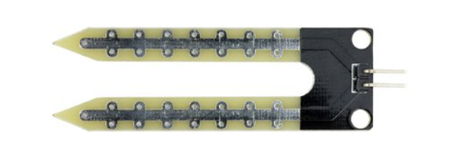

**The module** - The sensor also contains an electronic module that connects the probe to the Arduino.

The module produces an output voltage according to the resistance of the probe and is made available at an Analog Output (AO) pin.

The same signal is fed to a LM393 High Precision Comparator to digitize it and is made available at an Digital Output (DO) pin.

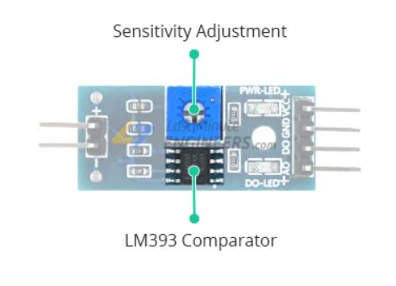

Apart from this, the module has two LEDs. The Power LED will light up when the module is powered. The Status LED will light up when the digital output goes LOW.

Connecting the probe with the module

There are 4 pins in the module.

1. The A0 pin gives us an analog signal between the supply value to 0V and will be connected to one of the analog inputs on your Arduino.
2. The digital output pin gives Digital output of internal comparator circuit. You can connect it to any digital pin on an Arduino or directly to a 5V relay or similar device.
3. The VCC pin supplies power for the sensor. It is recommended to power the sensor with between 3.3V – 5V.
4. Another is an GND pin.

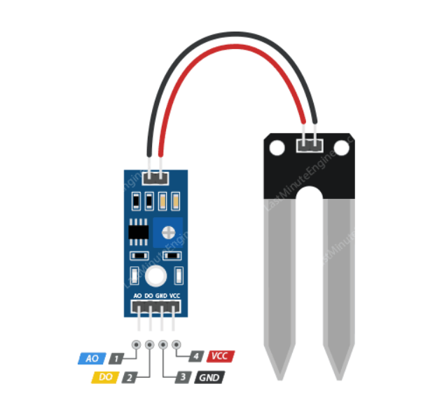

Connection

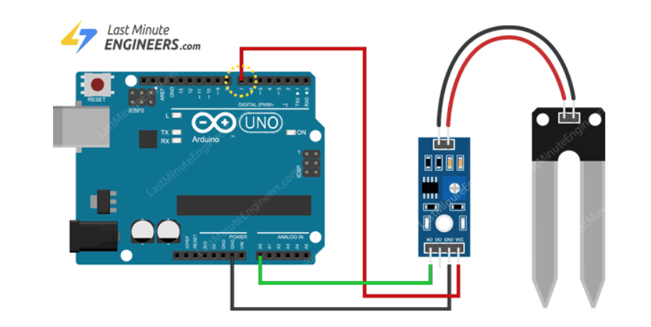

The VCC pin is connected with the 3.3v/5v power supply and the ground pin to the GND.

The A0 pin on module is connected with the A0 ADC pin on Arduino.

Program to get only the Analog signal value

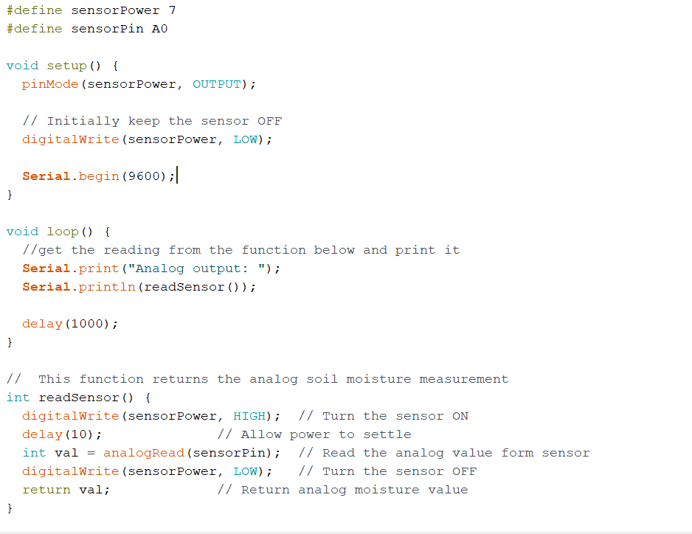

Output

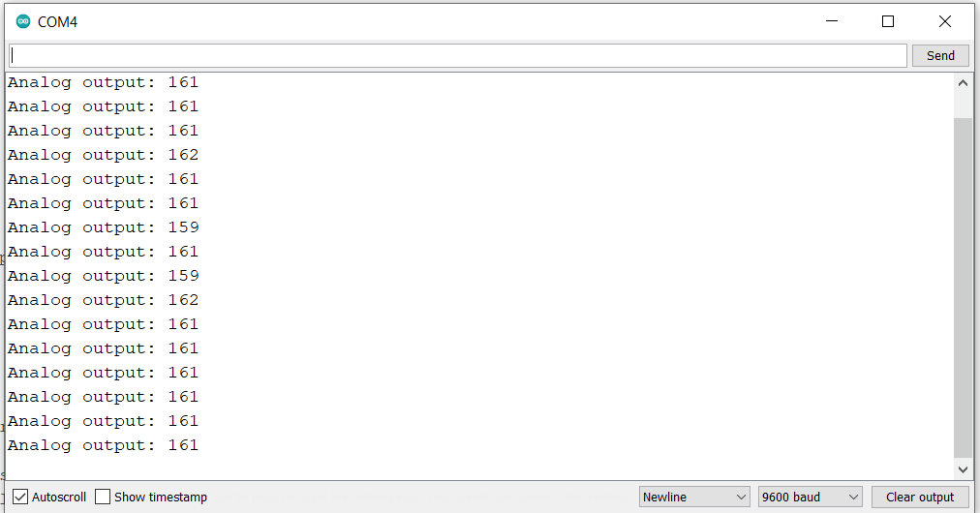

Program to set a threshold and check relative wetness

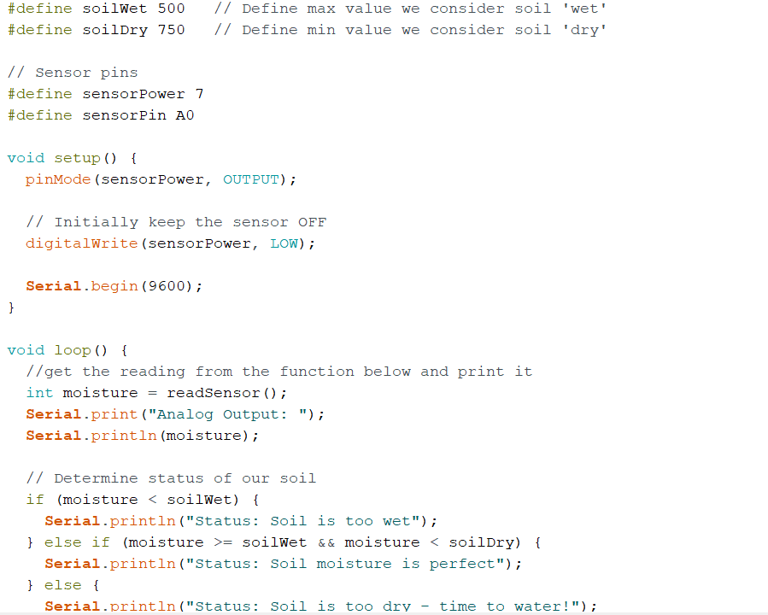

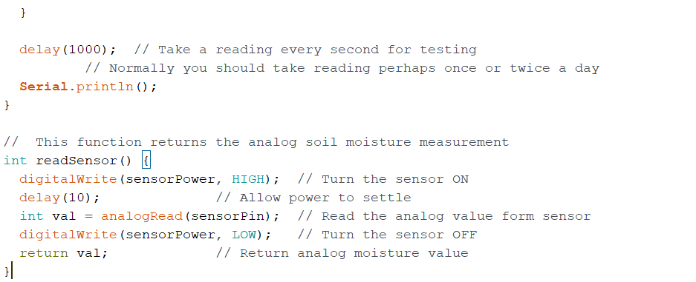

Output

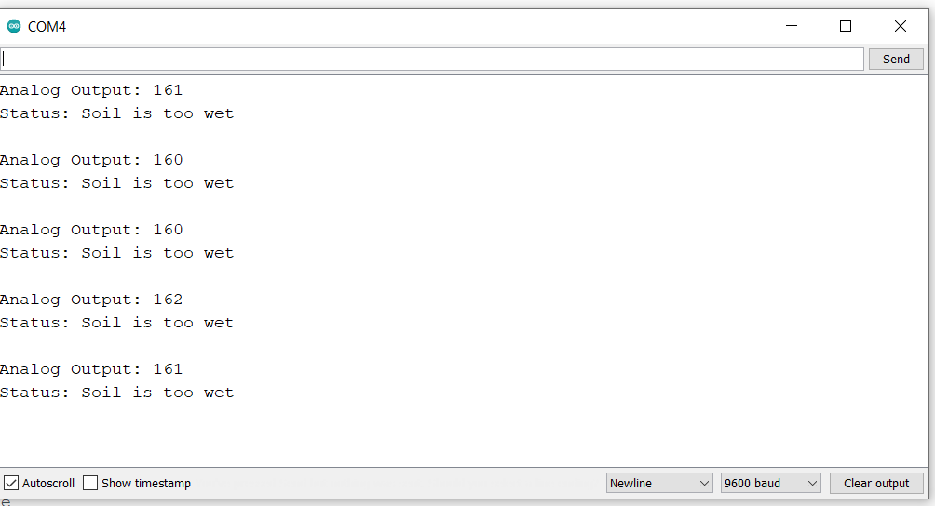

[reference](https://lastminuteengineers.com/soil-moisture-sensor-arduino-tutorial/)

Password generator program 2

import random

arr_chars = ["A", "B", "C", "D", "E", "F", "G", "H", "I", "J", "K", "L", "M", "N", "O", "P", "Q", "R", "S", "T", "U", "V", "W", "X", "Y", "Z", "a", "b", "c", "d", "e", "f", "g", "h", "i", "j", "k", "l", "m", "n", "o", "p", "q", "r", "s", "t", "u", "v", "w", "x", "y", "z"]

arr_nums = ['1','2','3','4','5','6','7','8','9']

arr_symbols = ['!','@','#','$','%','^','&','*','(',')','[',']','{','}']

def generate(chars,numbers,symbols):

    total_len = chars+numbers+symbols

    pswd = [0]*total_len

    index_arr = [x for x in range(0,total_len)]

    # print(index_arr)

    for i in range(0,2):

        index = random.randint(0,len(index_arr)-1)

        temp = random.randint(0,len(arr_chars)-1)

        pswd[index_arr[index]] = arr_chars[temp].upper()

        index_arr.remove(index_arr[index])

    for i in range(0,chars-2):

        index = random.randint(0,len(index_arr)-1)

        temp = random.randint(0,len(arr_chars)-1)

        pswd[index_arr[index]] = arr_chars[temp]

        index_arr.remove(index_arr[index])

    for i in range(0,numbers):

        index = random.randint(0,len(index_arr)-1)

        temp = random.randint(0,numbers-1)

        pswd[index_arr[index]] = arr_nums[temp]

        index_arr.remove(index_arr[index])

    for i in range(0,symbols):

        index = random.randint(0,len(index_arr)-1)

        temp = random.randint(0,symbols-1)

        pswd[index_arr[index]] = arr_symbols[temp]

        index_arr.remove(index_arr[index])

    new = ""

    for x in pswd:

        new+=x

    print(new)

chars = int(input("enter the number of characters you want to insert (min limit is 2)"))

if chars<2:

    print("invalid input, enter correctly")

else:

    numbers = int(input("enter the number of numbers you want (min limit is 1)"))

    if numbers<1:

        print("invalid input, enter correctly")

    else:

        symbols = int(input("enter the number of symbols you want (min limit is 1)"))

        if symbols<1:

            print("invalid input, enter correctly")

        else:

            generate(chars,numbers,symbols)

output

